Fiber Modem (ONT)

🔌 What is a Fiber Modem (ONT)?
# Source: Chatgpt (GPT‑5 Mini) at [12/18/2025]
A Fiber Modem, more accurately called an ONT (Optical Network Terminal), is a device that connects your home or office to a fiber-optic internet service. It converts light signals (used in fiber cables) into electrical signals that your network equipment (like a router) can understand.
✅ It’s the fiber equivalent of a cable or DSL modem — but for ultra-fast internet.

📶 What Does an ONT Do?
# Source: Chatgpt (GPT‑5 Mini) at [12/18/2025]
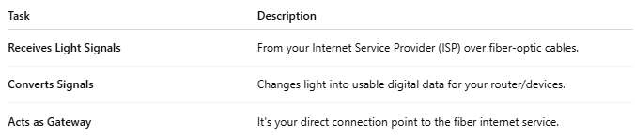
Task | Description
Receives Light Signals | From your Internet Service Provider (ISP) over fiber-optic cables.
Converts Signals | Changes light into usable digital data for your router/devices.
Acts as Gateway | It's your direct connection point to the fiber internet service.

🧱 Basic Setup Diagram
# Source: Chatgpt (GPT‑5 Mini) at [12/18/2025]
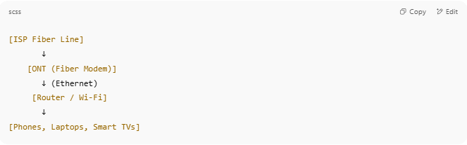

[ISP Fiber Line]
↓
[ONT (Fiber Modem)]
↓ (Ethernet)
[Router / Wi-Fi]
↓
[Phones, Laptops, Smart TVs]

- The ONT connects to your ISP’s fiber network.
- The ONT then connects (via Ethernet) to your router to share internet across your home.

🔧 Key Features of an ONT
# Source: Chatgpt (GPT‑5 Mini) at [12/18/2025]
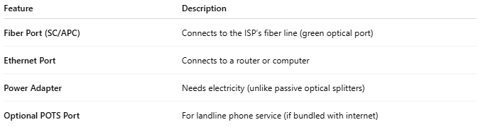

Feature | Description
Fiber Port (SC/APC) | Connects to the ISP’s fiber line (green optical port)
Ethernet Port | Connects to a router or computer
Power Adapter | Needs electricity (unlike passive optical splitters)
Optional POTS Port | For landline phone service (if bundled with internet)

📡 Speeds & Performance
# Source: Chatgpt (GPT‑5 Mini) at [12/18/2025]
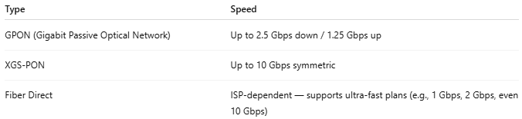

Type | Speed
GPON (Gigabit Passive Optical Network) | Up to 2.5 Gbps down / 1.25 Gbps up
XGS-PON | Up to 10 Gbps symmetric
Fiber Direct | ISP-dependent — supports ultra-fast plans (e.g., 1 Gbps, 2 Gbps, even 10 Gbps)

🆚 ONT vs Modem
# Source: Chatgpt (GPT‑5 Mini) at [12/18/2025]
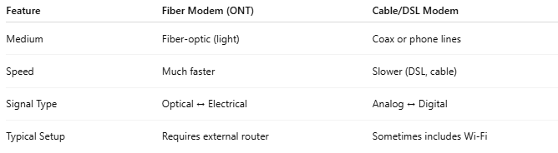

Feature | Fiber Modem (ONT) | Cable/DSL Modem
Medium | Fiber-optic (light) | Coax or phone lines
Speed | Much faster | Slower (DSL, cable)
Signal Type | Optical ↔ Electrical | Analog ↔ Digital
Typical Setup | Requires external router | Sometimes includes Wi-Fi
📌 Many ISPs provide the ONT — you just plug in your own router.

✅ Pros
# Source: Chatgpt (GPT‑5 Mini) at [12/18/2025]
- ✅ Very high speeds (1–10+ Gbps)
- ✅ Low latency (great for gaming/VoIP)
- ✅ Stable and interference-free connection
- ✅ More future-proof than copper-based internet

❌ Cons
# Source: Chatgpt (GPT‑5 Mini) at [12/18/2025]
- ❌ Requires professional installation
- ❌ You may not own the ONT (it's often ISP-provided)
- ❌ No built-in router or Wi-Fi — must add your own

